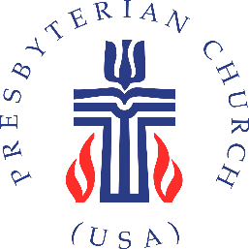

**Enduring Witness Team**

**Grant Inquiry Application**

**The Enduring Witness Team is offering grants to congregations to support your ministry.**

**To begin the conversation about your congregation’s funding needs, please complete and return the form below.**

|  |  |
| --- | --- |
| **Date** |  |

|  |  |
| --- | --- |
| **Congregation Name and Town** |  |

**Applicant contact information**

|  |  |
| --- | --- |
| **Name** |  |
| **Email** |  |
| **Phone** |  |

|  |  |
| --- | --- |
| **Position in the Congregation (Pastor, Elder, Treasurer, etc.)** |  |

|  |  |  |
| --- | --- | --- |
| What is the amount of your grant request? | $ |  |

Has your session voted to approve this initial application? _____ Yes _____ No

**Please fill out or attach the following questions to the application.**

1. What do you want to use the money to do?
2. Why is this important?
3. Does this affect or have an impact on anyone outside your congregation? Who and how?

**Please return completed application to the Enduring Witness Team via:**   
Email: [enduringwitness@presbyteryofli.org](mailto:enduringwitness@presbyteryofli.org)

or

Mail: Presbytery of Long Island

Attn: Enduring Witness Team

109 Udall Rd. West Islip, NY 11795