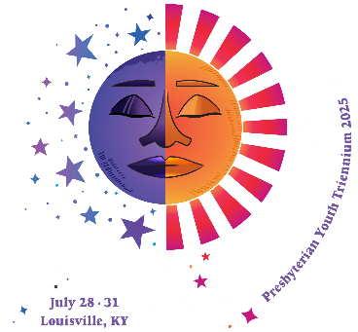

Presbytery of Long Island 2025 Triennium
Participant Application
Applicant Full Name:
Badge Name:
Identifying Gender: | Birthdate: | Age at PYT:
Role at PYT (Circle One):
Youth Participant Adult Advisor Workcrew Global Partner Caregiver
Applicant Email:
Applicant Cell:
T-shirt Size:
Applicant Church Name/City:

Any special needs that leadership should be aware of?

Why would you like to attend the Presbyterian Youth Triennium Conference 2025?

The theme for the 2025 Triennium, is based on one of the psalms about people who were lost and how God restored their hope and brought them back home. The only way they could describe their experience was that it was “as if we were dreaming.” .
What does this make you think of?

Traveling to and from the Triennium, participating in the event, you will be a part of several new communities (your delegation, your small group, your residence hall, the whole PYT community). What does it mean to you to be in a community? What will you bring to the community?

What kind of an impact can come from an event like the Triennium? On you? On your church? On the larger church?

Is there anything else you’d like to tell the leaders of your delegation?

