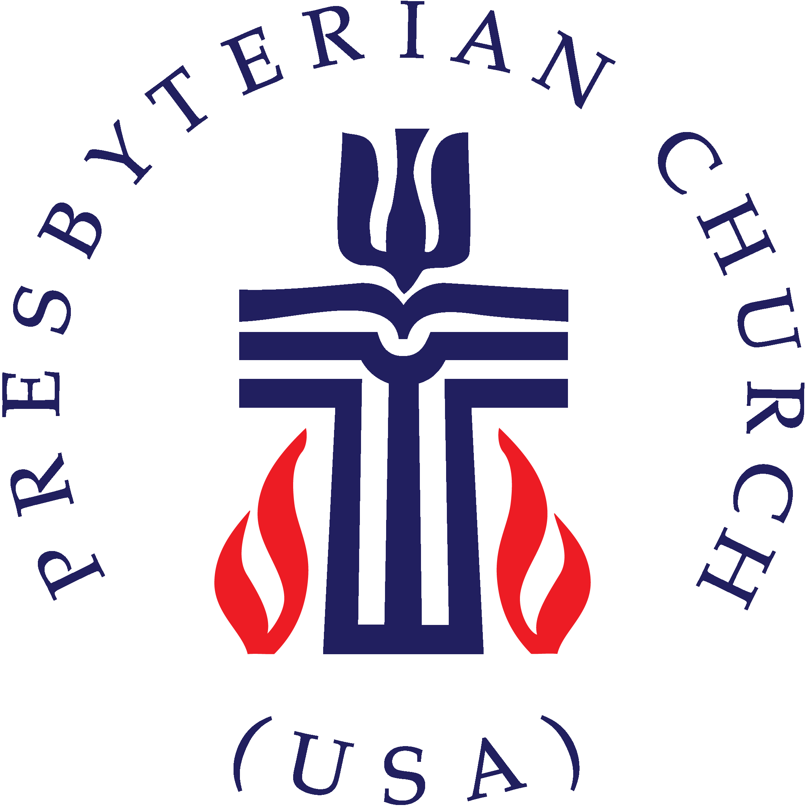

***This certifies that***

***NAME***

***Upon confession on faith   
has been baptized***

***on the Twenty-Seventh Day of January in the Year of our Lord 2019***

***at CHURCH***

NAME, Clerk of Session

NAME, Pastor

***CERTIFICATE OF Baptism***